
SHIRE HIGHLANDS EDUCATION DIVISION
2025 MALAWI SCHOOL CERTIFICATE OF EDUCATION MOCK
EXAMINATION

PHYSICS
Subject Number: M164/I
Monday, 31st March, Time Allowed: 2 hours
8:00 - 10:00 am
PAPER I
Theory
(100 Marks)
Instructions
- This paper contains 10 printed pages. Please check.
- Write your name at the top of each page.

- This paper contains two sections A and B. In Section A there are short answer questions while in Section B there are restricted essay questions.

- Answer all the thirteen questions in the spaces provided.

- The maximum number of marks for each answer is indicated against each question.

- In the table provided on this page, tick against the number of the question you have answered.

© 2025 SHED MOCK
Question  Number | Tick if  answered | Do not write in these columns
1
2
3
4
5
6
7
8
9
10
11
12
13
Turn over
Section A (70 marks)
Answer all the ten questions in the spaces provided.
- a. i. State Newton’s second law of motion.
___________________________________________________________________________________________________________________________________________ (1 mark)
ii. Calculate the horizontal component of an 8N force acting at an angle of 30⁰ with the
horizontal plane.

(3 marks)
b. i. Give any one factor that affect the magnitude of centripetal force on a body
negotiating a roundabout.
________________________________________________________________ (1 mark)
ii. A 6kg rock swings in a circular path of radius 3.2m. If its constant speed is 10m/s, Calculate the centripetal acceleration.

(3 marks)
- a. Figure 1 shows a velocity – time graph for the motion of a body of mass 2 kg
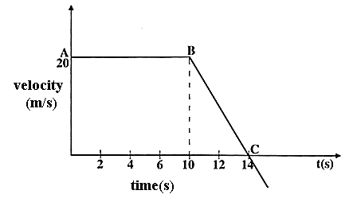
Figure 1
Calculate the force acting on the body from point B to C.

(3 marks)

b. Figure 2 shows a pulley system used to raise a load by applying an effort of 500 N.
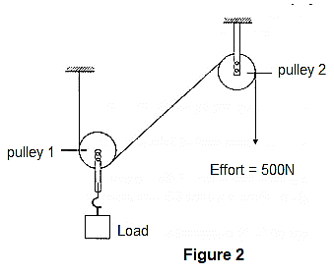

i. Determine the velocity ratio of the system
_____________________________________________________________ (1 mark)
ii. Given that the machine has the efficiency of 80%, calculate the maximum load that
machine can be raised.

(4 marks)
- a. Explain why artificial radioactive isotopes are used in research.
____________________________________________________________________________________________________________________________________________ (2 marks)
b. Give any two examples where radioactive isotopes are used as tracers
____________________________________________________________________________________________________________________________________________ (2 marks)
- a. Describe the use of liquid pressure in the construction of dams
____________________________________________________________________________________________________________________________________________(2 marks)
b. A syringe contain 5cm³ of gas at a temperature of 23⁰C. Calculate the temperature in
kelvin of the gas in the springe if the volume is doubled at constant pressure.

(3 marks )

c. Using kinetic theory of gases, why does the pressure of the air inside a car tyre
increases if the car stands out in the sun for some time on a hot day?
____________________________________________________________________________________________________________________________________________________________________________________________________________________________________________________________________________________________ (3 marks)
- a. i. Arrange the following waves in order of decreasing wavelength; infra-red, microwaves
and visible light.
___________________________________________________________________(1 mark)
ii. State any two uses of microwaves
__________________________________________________________________________________________________________________________________________ (2 marks)
- Figure 3, shows a graph of magnification against object distance, for an object placed in front of a lens of focal length 20cm
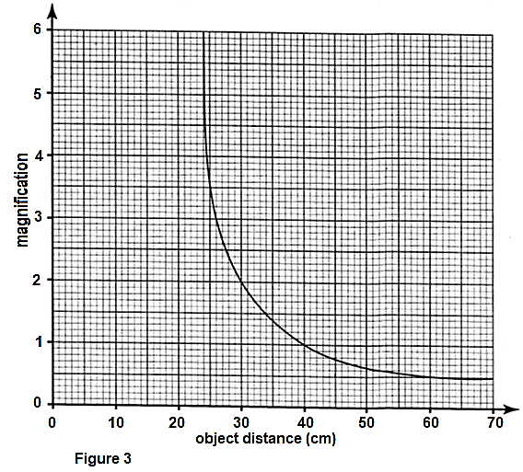
Using the graph;
- state the effect on the size of the image as the object distance is increased from 25cm
______________________________________________________________ (1 mark)
- determine the object distance when the image is the same size as the object
___________________________________________________________________________________________________________________________________ (2 marks)
- Determine the image distance when the object distance is 27.5 cm

(3 marks)
- Figure 4 shows a braking system.
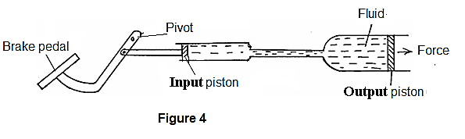
a. State the any one quality of fluid in the system.
__________________________________________________________________ (1 mark)
b. If the force of 45N acts on input piston of area 0.4m², calculate the force on the output piston of area 0.9m².

(3 marks)
- a. How does a fuse work in protecting the electrical device?
______________________________________________________________________________________________________________________________________________________________________________________________________________________ (3 marks)
- Two energy saver bulb rated 18W each are used for 10 hours per day for 15 days. Calculate the total bill if the cost per unit is K109 and total levies is K1,750.

(3 marks)

c. Figure 5 shows a soft iron bar being magnetized by a current through the solenoid
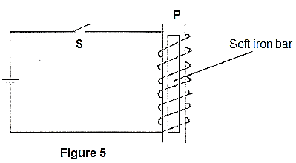
- On the diagram, show the direction of the current on the turns when the switch S is closed. (1 mark)
- State the polarity at P.
_____________________________________________________________(1 mark)
- Explain using domain theory what happens on the soft iron bar.
____________________________________________________________________________________________________________________________________________________________________________________________________ (3 marks)
- a. Name two conditions necessary for interference of two waves
____________________________________________________________________________________________________________________________________________ (2 marks)
b. Figure 6 shows the displacement- time and displacement-distance graphs of a
certain wave.
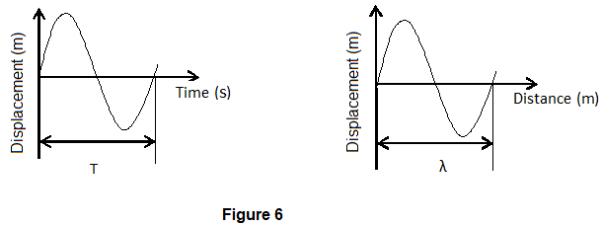

From the information above show that the speed of the $wave = frequency × wavelength$ (v = f λ).

( 3 marks)

- a. i. State the Lenz’s law
___________________________________________________________________________________________________________________________________________ (1 mark)
ii. Give any two factors that affects the efficiency of a transformer.
________________________________________________________________________________________________________________________________________________________________________________________________________________ (2 marks)
- Explain how change in temperature affect the conductivity of semiconductors.
______________________________________________________________________________________________________________________________________________________________________________________________________________________ (2 marks)
- The voltmeter reads 1.5V when the switch is open and 1.3V when the switch is closed. Calculate internal resistance of the cell if the current of 0.5A flow in the circuit.

(3 marks)
- a. Express $0.000 000 510 meters$,
- in standard notation
___________________________________________________________ (1 mark)
ii. in micrometers
___________________________________________________________ (1 mark)
b. State how a random error can be minimized during experimental data collection.
_________________________________________________________________ (1 mark)
c. Explain why it is important to include references when writing an experimental laboratory report __________________________________________________________________________________________________________________________________________ (2 marks)

Section B (30 marks)
Answer all the three questions in this section in an essay form in the spaces provided.
- a. With the aid of a diagram, describe how a Six’s maximum and minimum thermometer
works.

______________________________________________________________________________________________________________________________________________________________________________________________________________________________________________________________________________________________________________________________________________________________________________________________________________________________________________________________________________________________________________________________________________________________________________________________________________________________________________________________________________________________________________________________________________________________________________________________________________________________________(6 marks)

- Explain how germanium crystal becomes an n–type semiconductor when doped with arsenic and becomes p–type semiconductor when doped with boron.
(Number of electrons in the outermost shell of Germanium = 4, Arsernic = 5, Boron = 3) _____________________________________________________________________________________________________________________________________________________________________________________________________________________________________________________________________________________________________________________________________________________________________________________________________________________________________________________________________________________________________________________________________________________________________________________________________________________________________________________________________________________________________________________________________________________________________________________________________________________________________ (4 marks)
- a. Describe the motion of the body falling in air until it attain its terminal velocity.
__________________________________________________________________________________________________________________________________________________________________________________________________________________________________________________________________________________________________________________________________________________________________________________________________________________________________________________________________________________________________________________________________________________________________________________________________________________________________________________________________________________________________________________________________________________________________________________________________________________________________________________________________________________________________________________________________________________________________________________________(4 marks)

b. With an aid of diagram, describe an experiment that can be done to locate the center of
mass of an irregular lamina.

____________________________________________________________________________________________________________________________________________________________________________________________________________________________________________________________________________________________________________________________________________________________________________________________________________________________________________________________________________________________________________________________________________________________________________________________________________________________________________________________________________________________________________________________________________________________ (6 marks)
- a. Describe an experiment to find out whether the size of mass mounted on
an oscillating spiral spring affects its frequency.
__________________________________________________________________________________________________________________________________________________________________________________________________________________________________________________________________________________________________________________________________________________________________________________________________________________________________________________________________________________________________________________________________________________________________________________________________________________________________________________________________________________________________________________________________________________________________________________________________________________________________________________________________________________________________________________________________________________________________________________________ (6 marks)

b. Hoe does the pressure law agrees with the kinetic theory of matter
___________________________________________________________________________________________________________________________________________________________________________________________________________________________________________________________________________________________________________________________________________________________________________________________________________________________________________________________________________________________________________________________________________________________________________________________________________________________________________________________________________________________________________________________________________________________________________________________________________________________________________________________________________________________________________________________________________________________________________________________________________________________________________________________________________________________________________________________________________________________________________________________________________________________________________________________________________________________________________________________________________________________________________ (4 marks)
END OF QUESTION PAPER
NB: This paper contains 10 printed pages.

